SETTING UP PYTHON

1. Install python 3.12.1

**attach screen capture of `python –version` command.**

1. Create a folder for your class files, make a python virtual environment called *venv* in this folder, activate it, and

**attach screen capture of `python –version` command.**

Create a notebook called *My First Notebook*, execute a print statement to print your name and

**attach screen capture**

1. Pick one other IDE from this [listLinks to an external site.](https://hackr.io/blog/best-python-ide" \t "_blank) (I like VS code) and create a python script that’s prints your name, run it, and

**show a screen capture with the IDE and the output.**

SETTING UP GIT.

1. If you do not have one, create an account on [https://github.com/Links to an external site.](https://github.com/).  Initialize a repository for your class files,  add and commit myname.py to the repository on your local machine, commit changes, and push it to GitHub.

**Show a screen capture with your GitHub repository.**

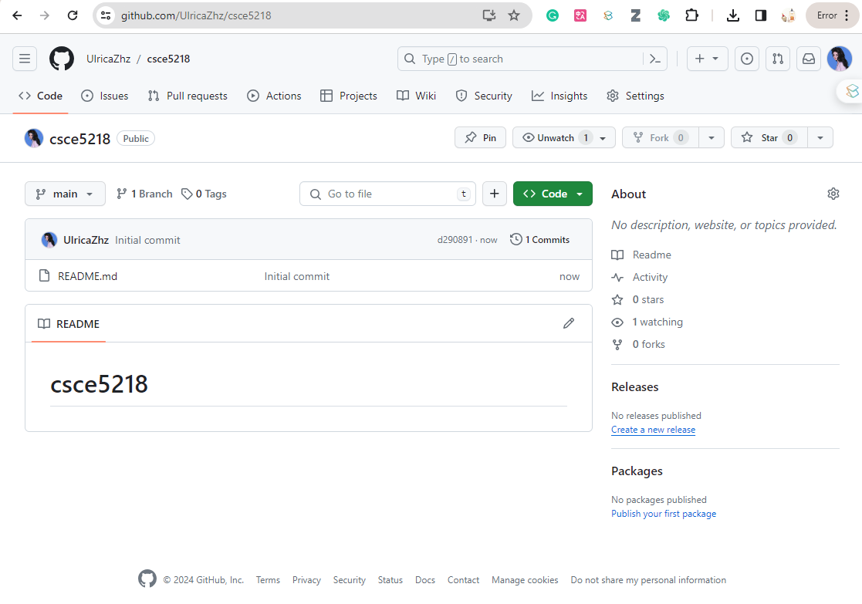

**Also provide the link here:** [**https://github.com/UlricaZhz/csce5218**](https://github.com/UlricaZhz/csce5218)